**AWS COURSE**

**-BY ETHNUS CODEMITHRA**

**AWS**

1. **LOGIN SCREENS**

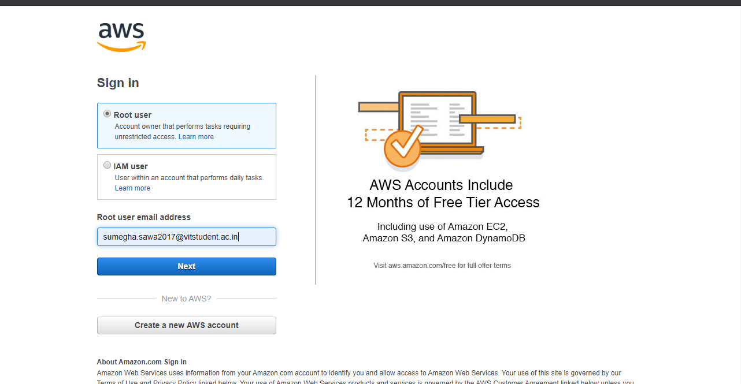

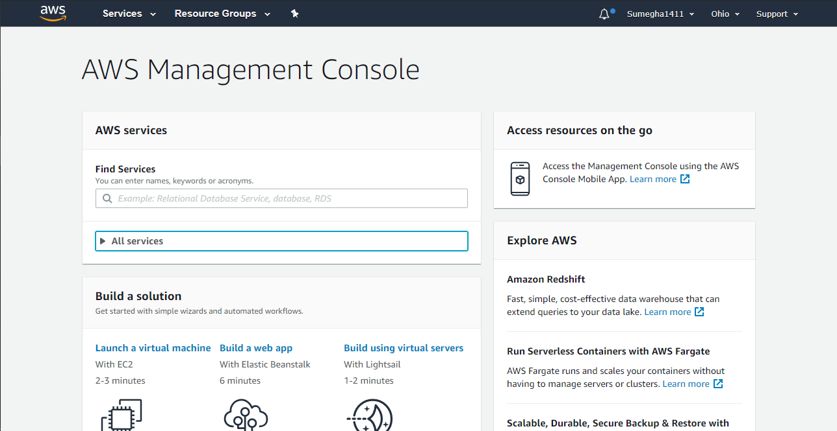

1. **EC2 DASHBOARD**

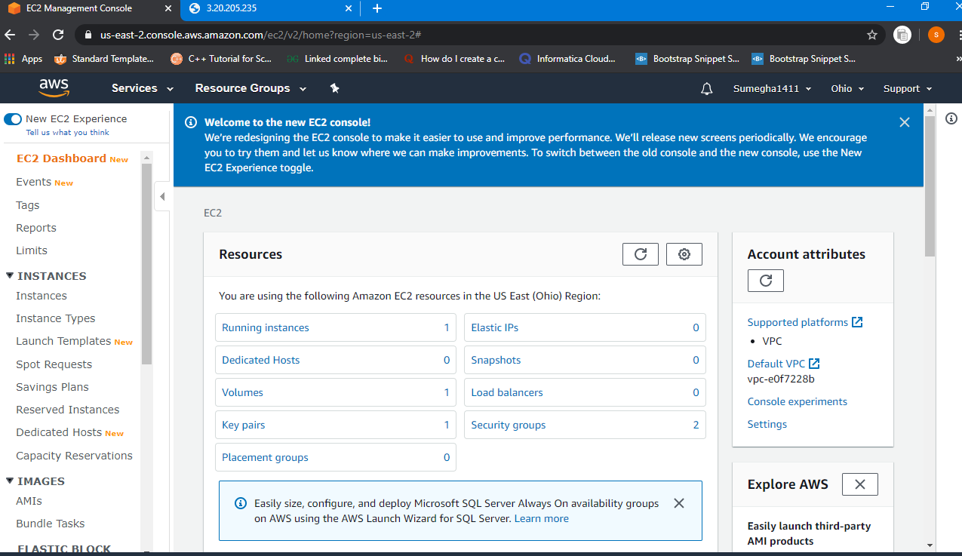

1. **S3 DASHBOARD**

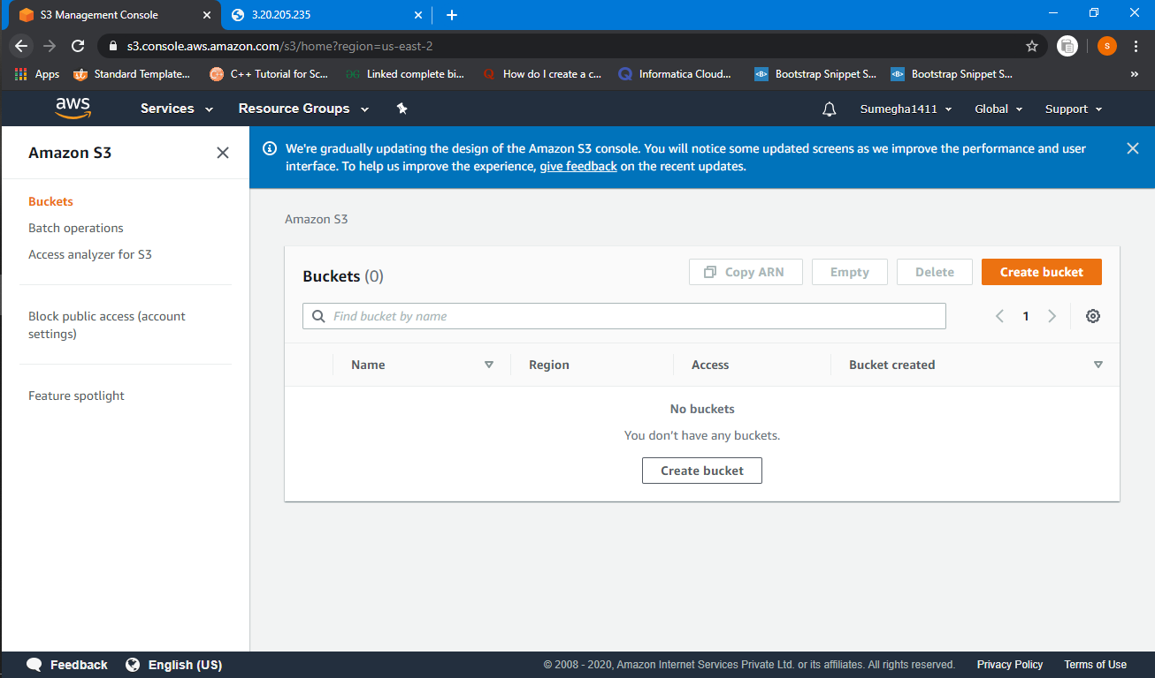

1. **REKOGNITION DASHBOARD**

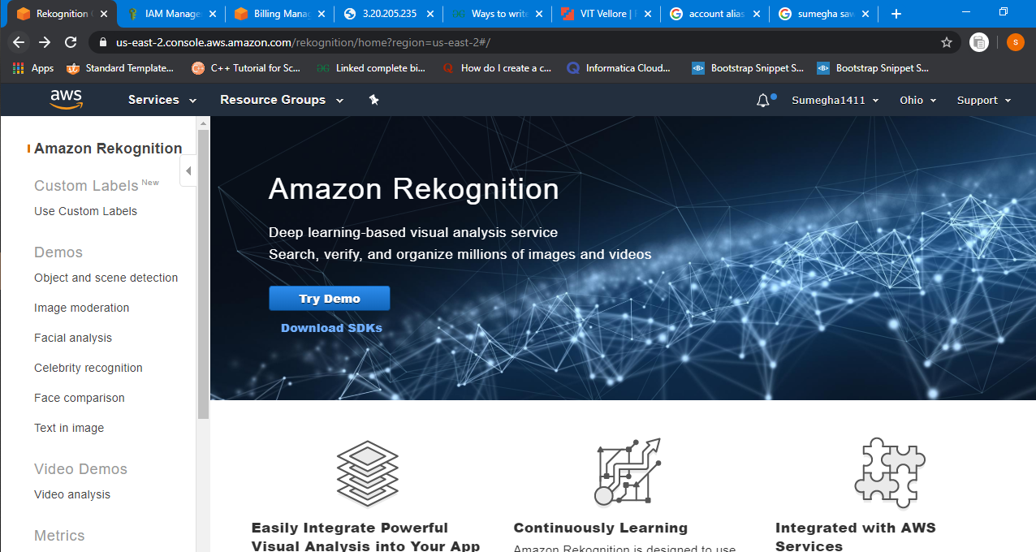

**EC2**

1. **CHOOSING OF AMI**

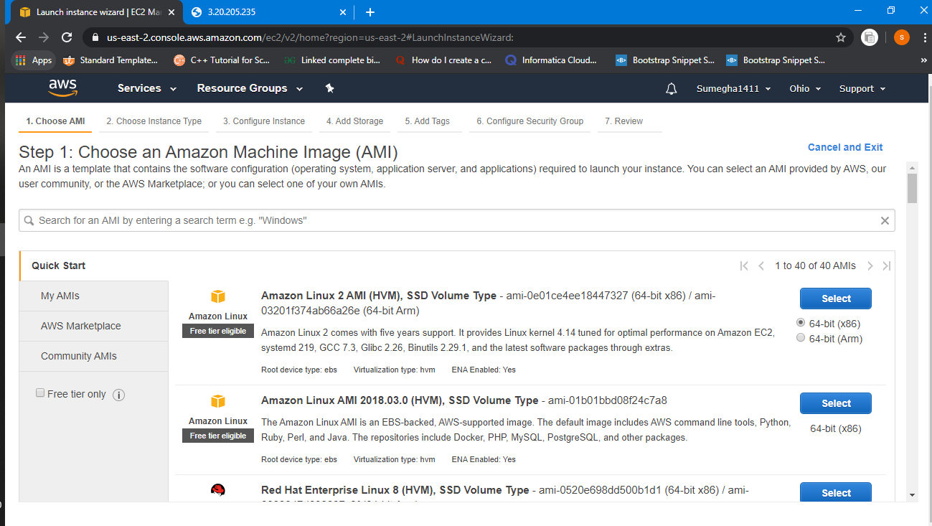

1. **CHOOSING OF INSTANCE TYPE**

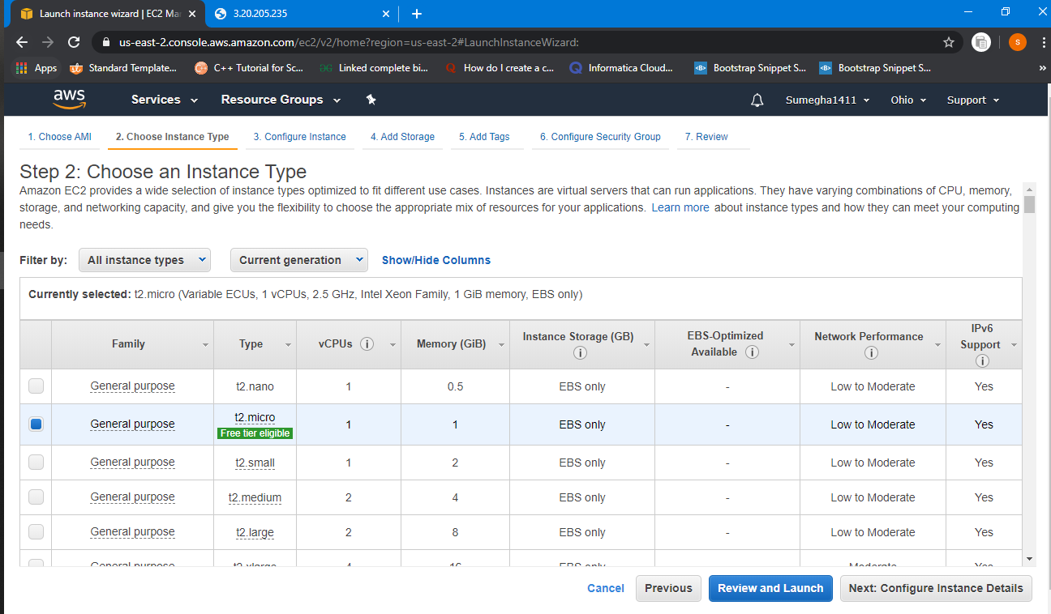

1. **ADD STORAGE**

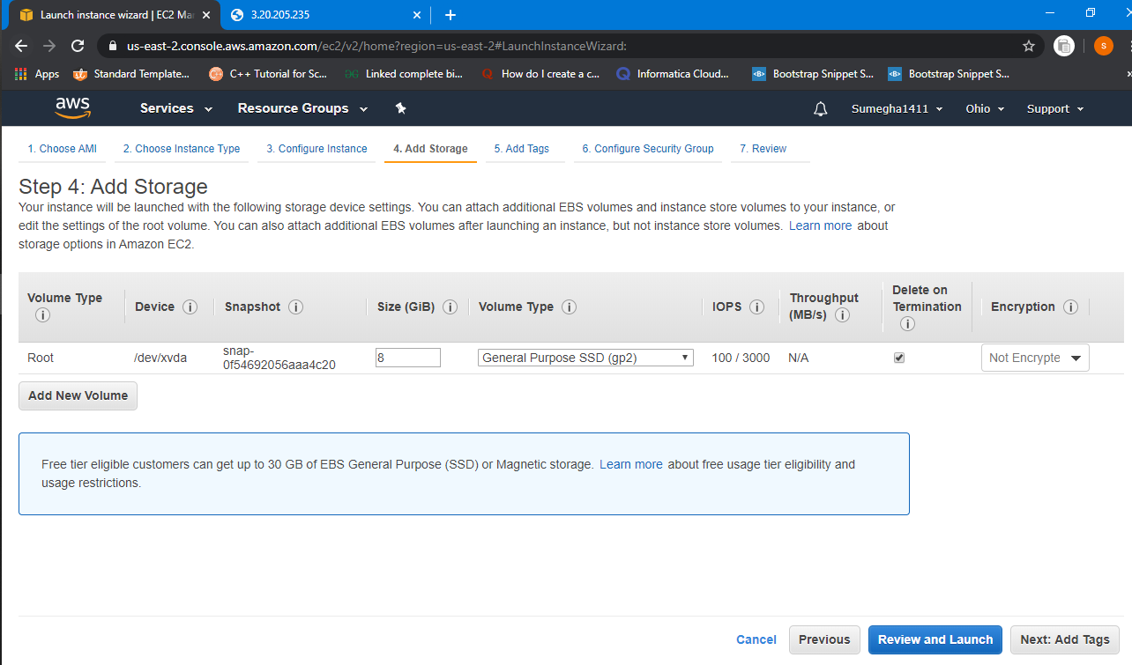

1. **CONFIGURING SECURITY GROUP**

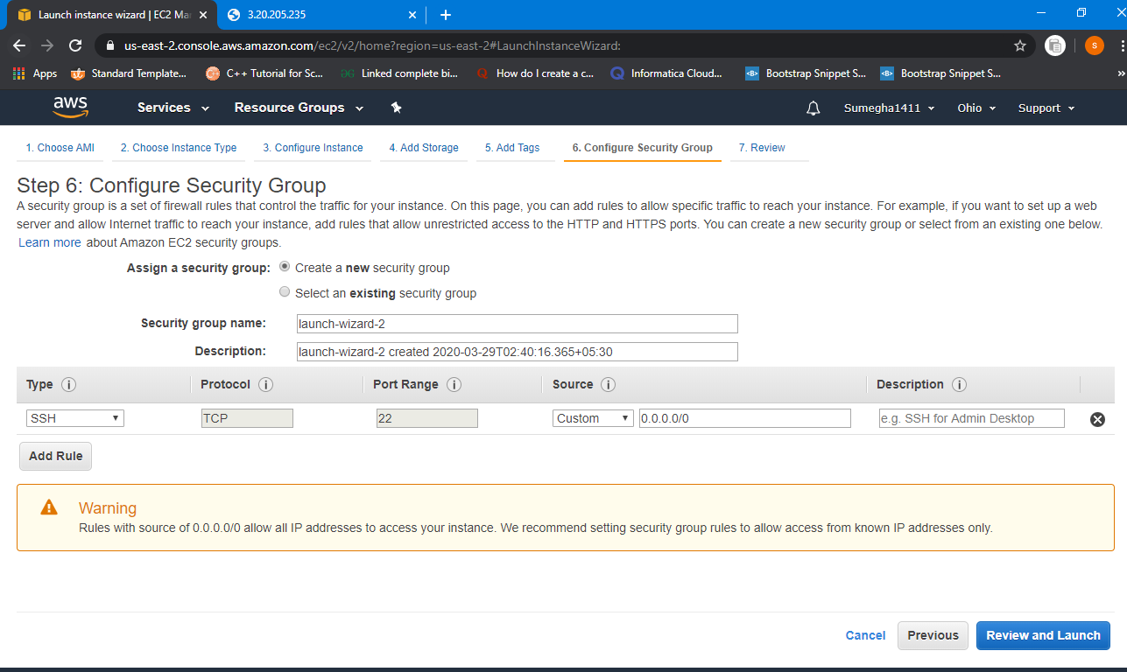

One instance is running which was build during demo.

1. **SELECTION/DOWNLOAD OF KEY PAIR**

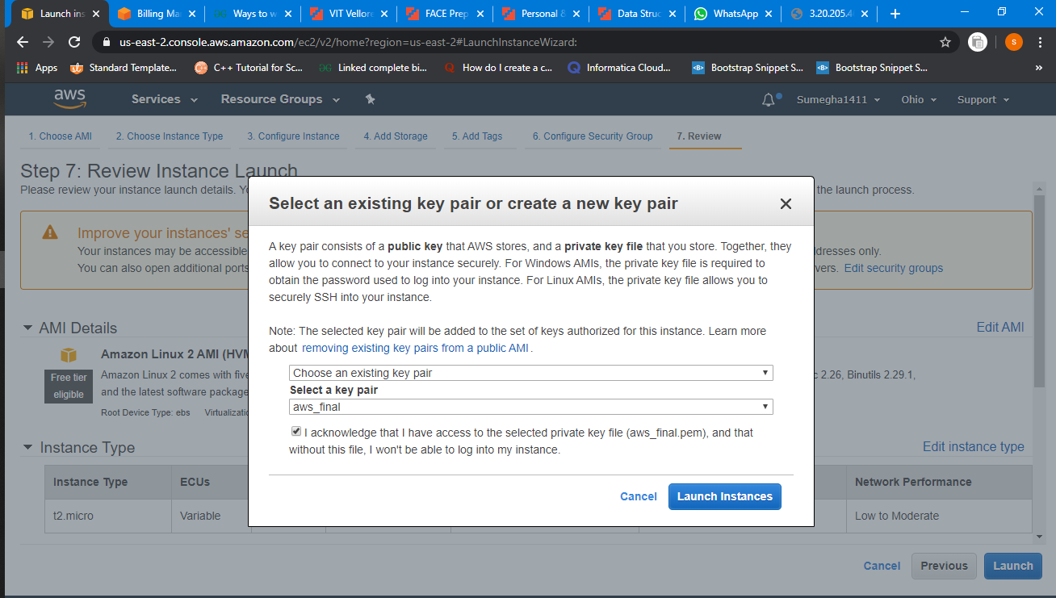

1. **PUTTYGEN CONVERSION FROM PEM TO PPK**

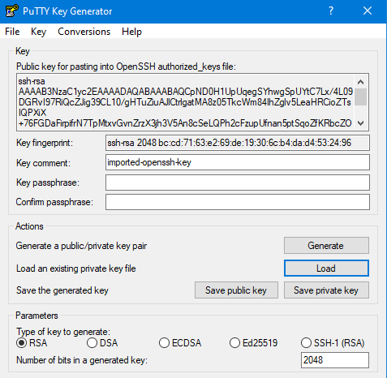

INSTANCE LAUNCED

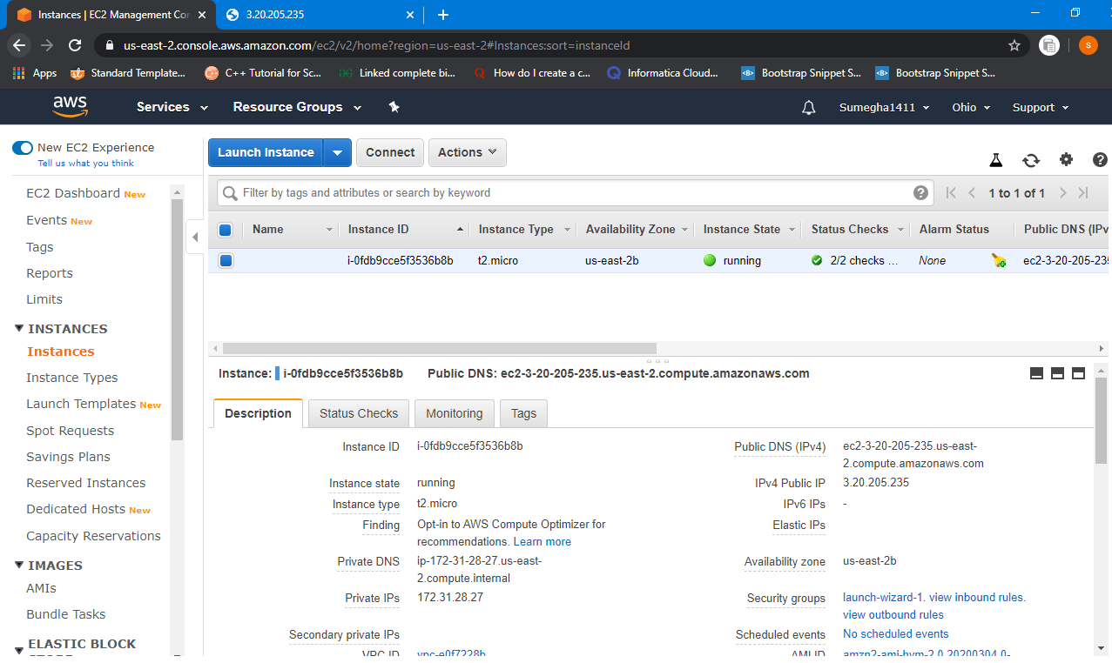

1. **LOGGED IN EC2 BLACK SCREEN**

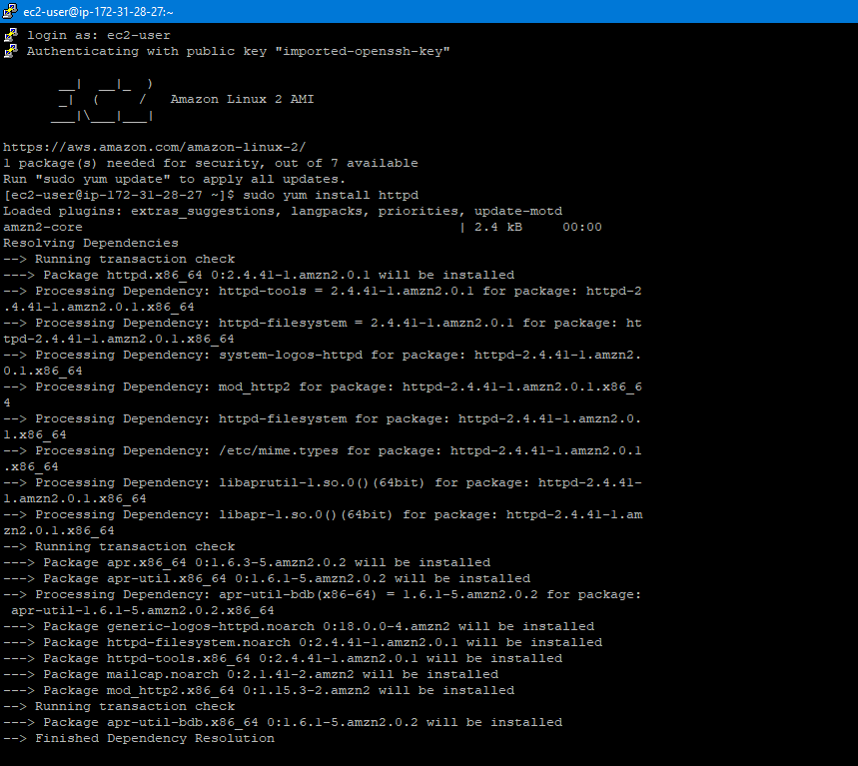

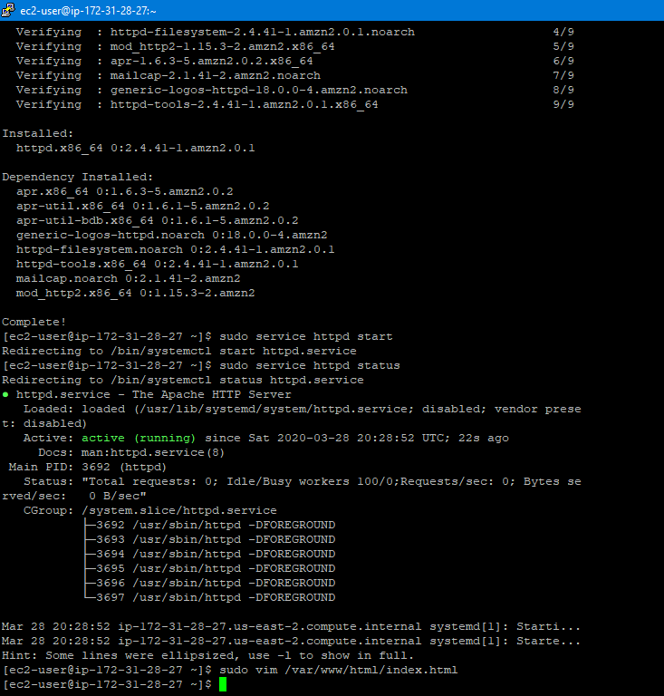

SETTING SECURITY GROUP

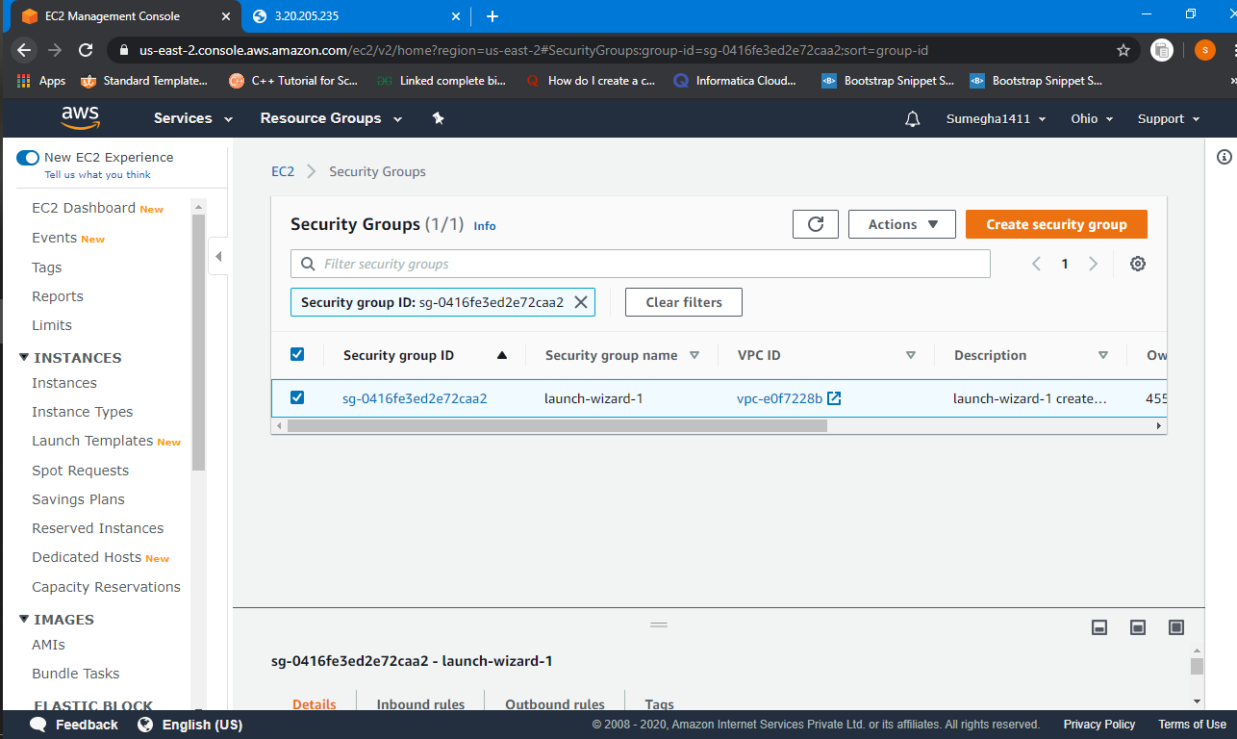

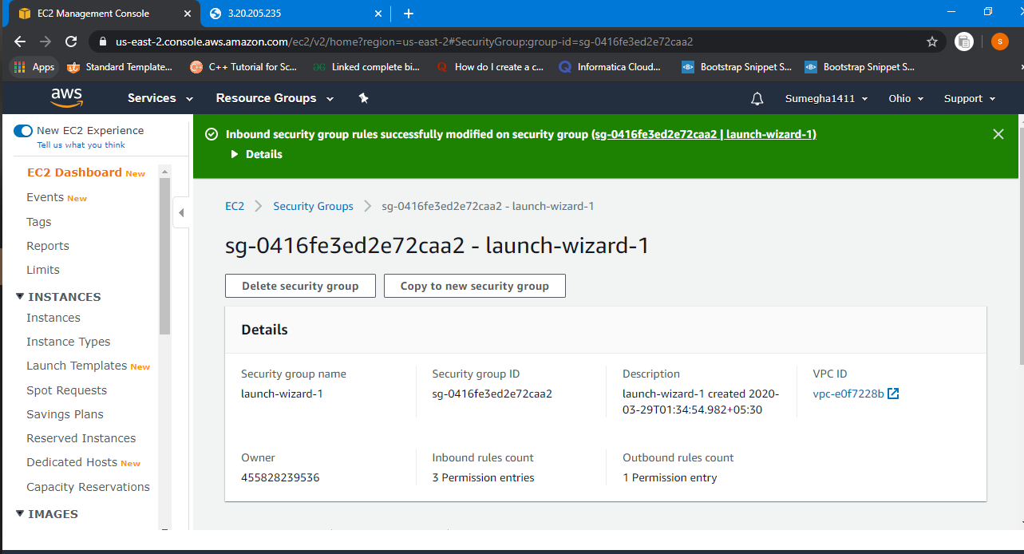

SECURITY GROUP SET TO HTTP

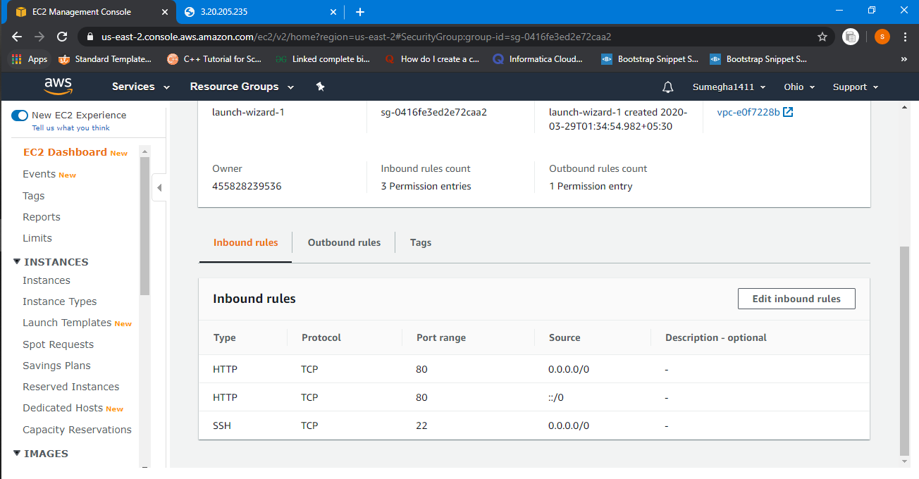

BROWSER DISPAY DEMO OF EC2

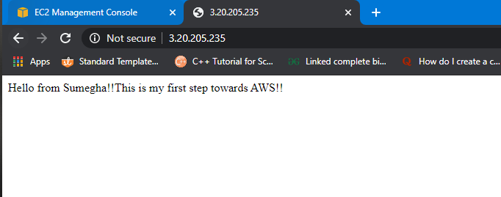

**S3**

1. **CREATE BUCKET**

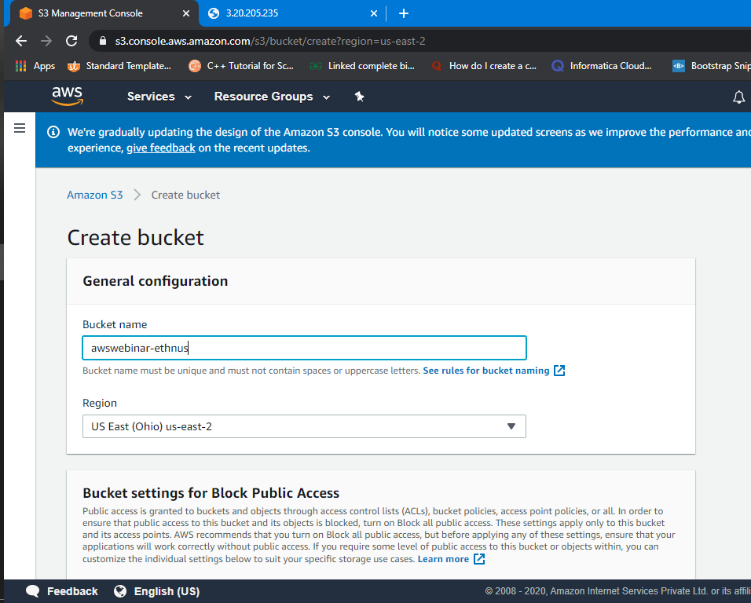

BUCKET CREATED

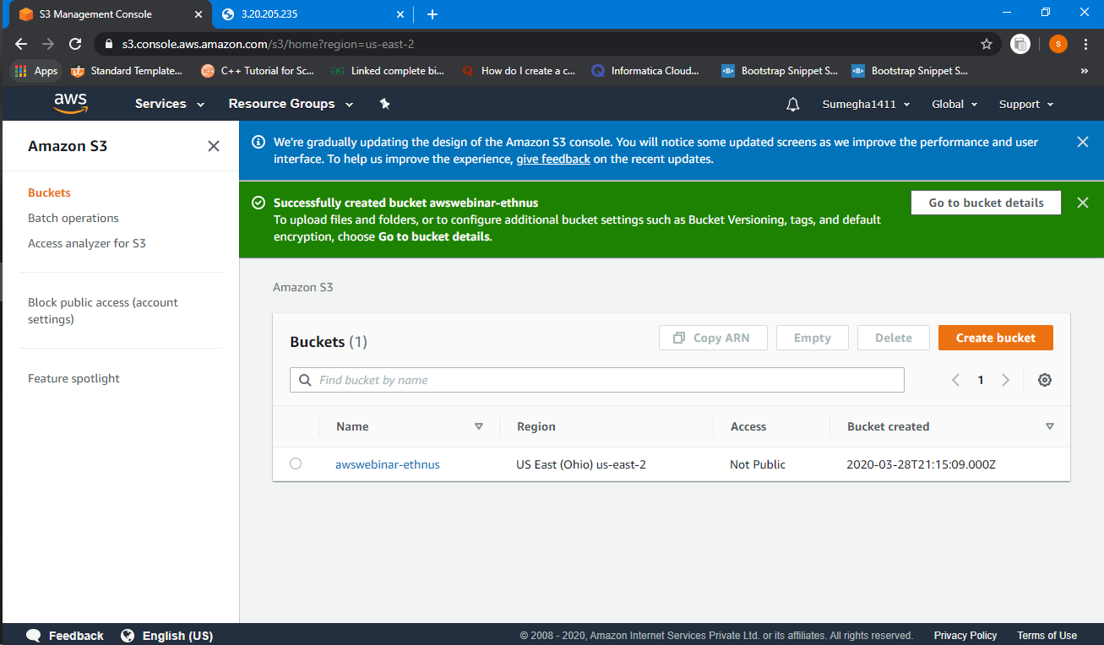

EMPTY BUCKET(NO OBJECT)

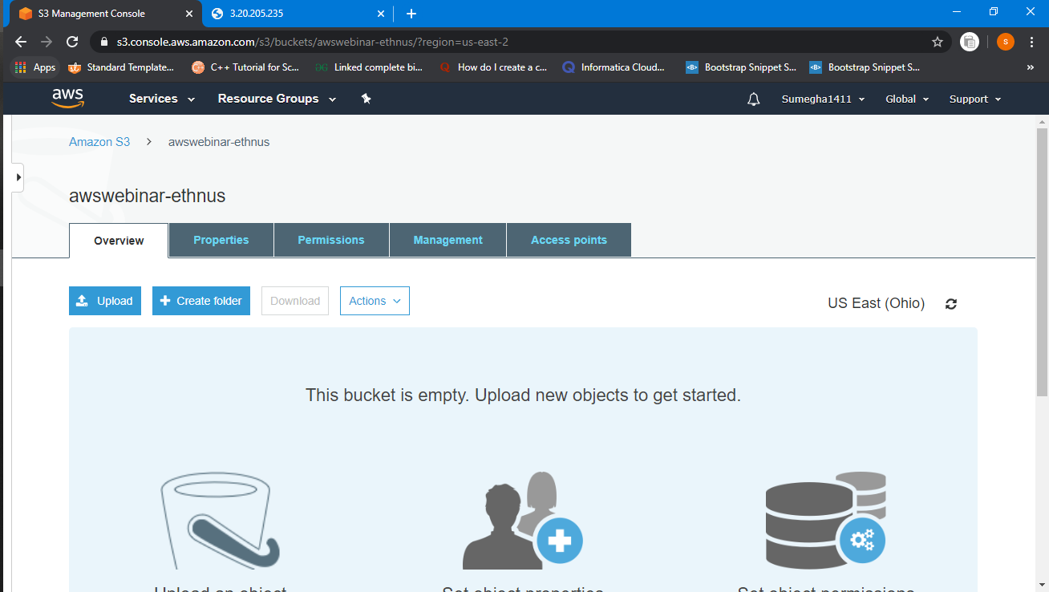

1. **UPLOADING A OBJECT(index.html)**

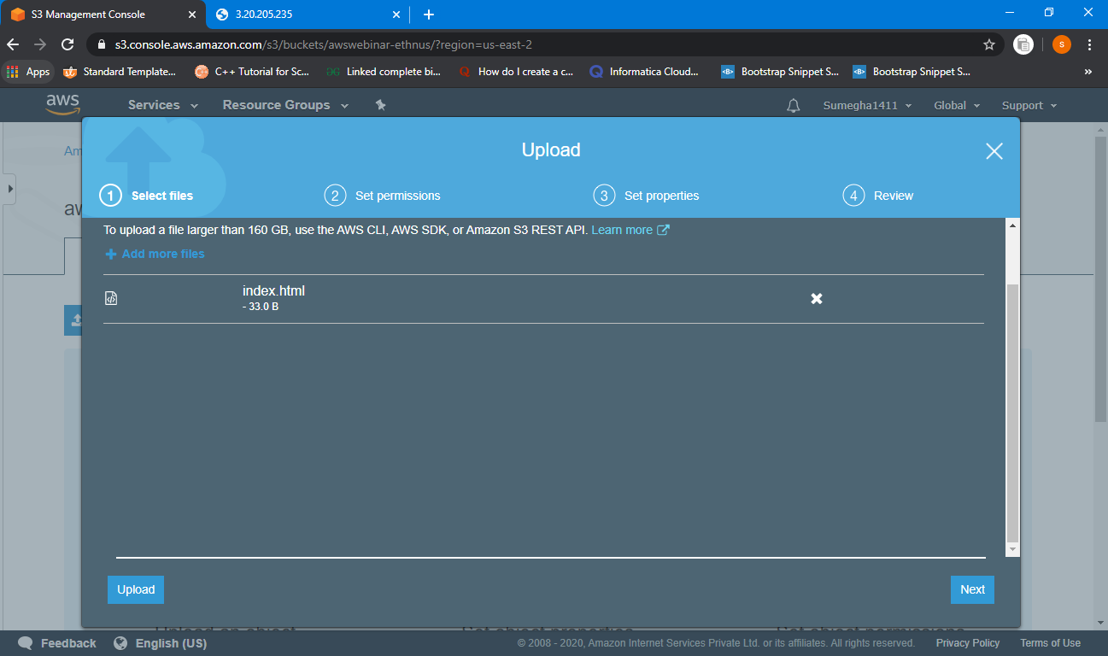

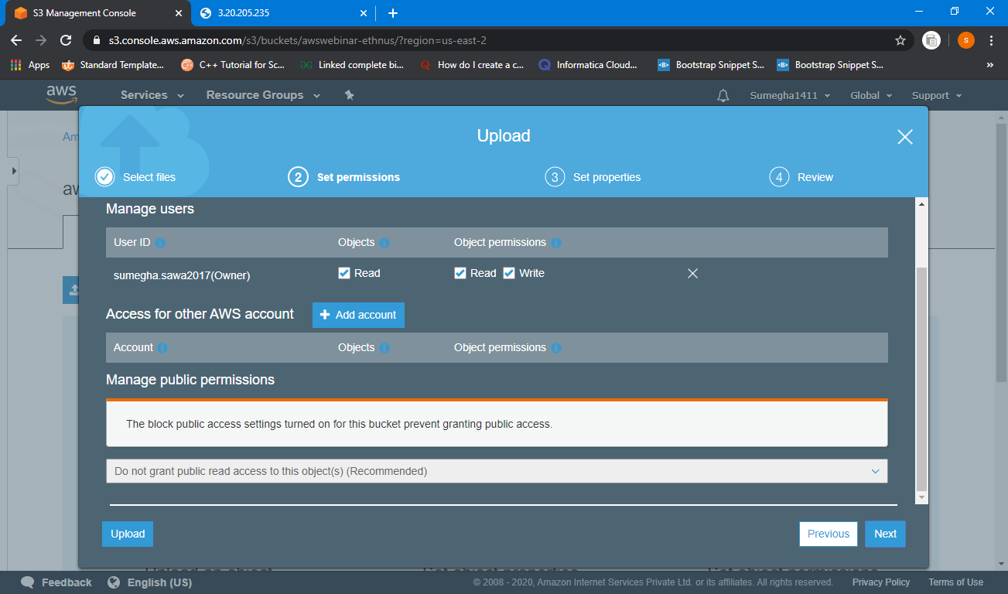

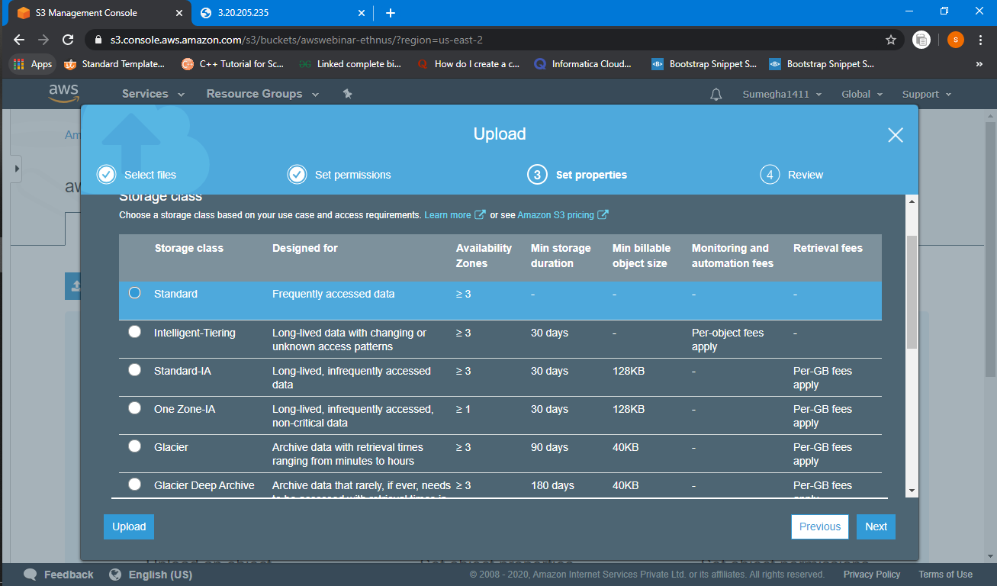

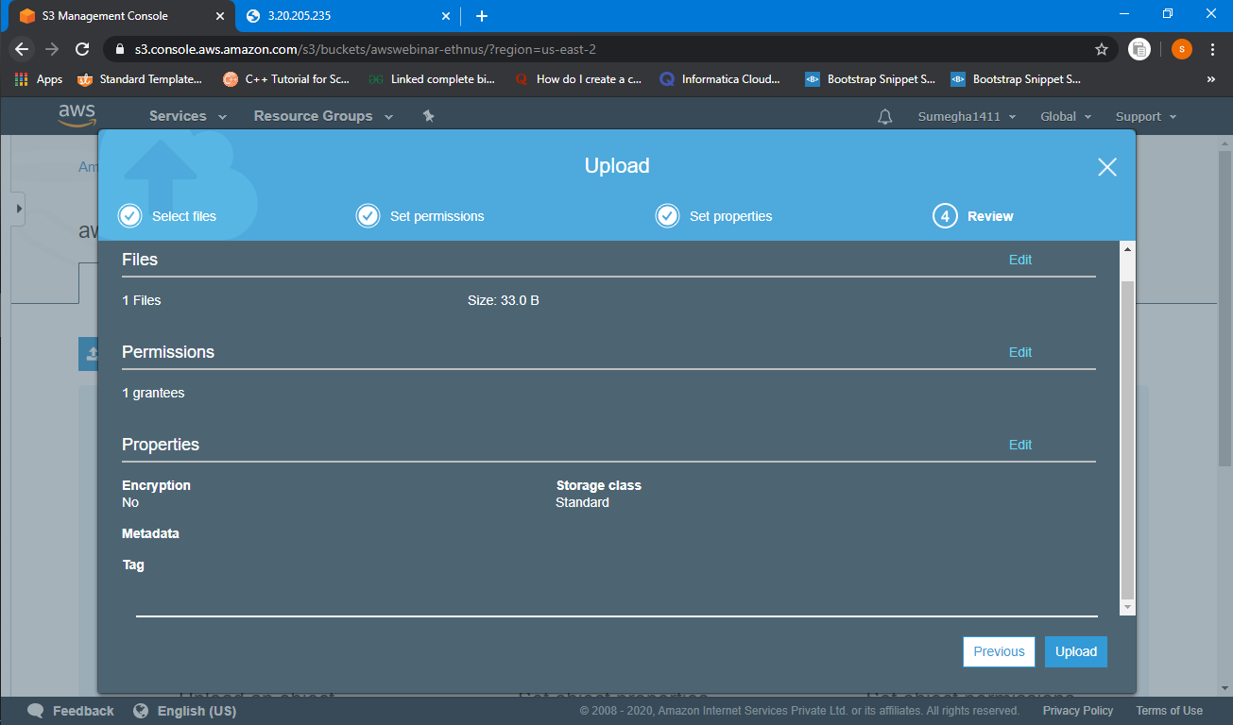

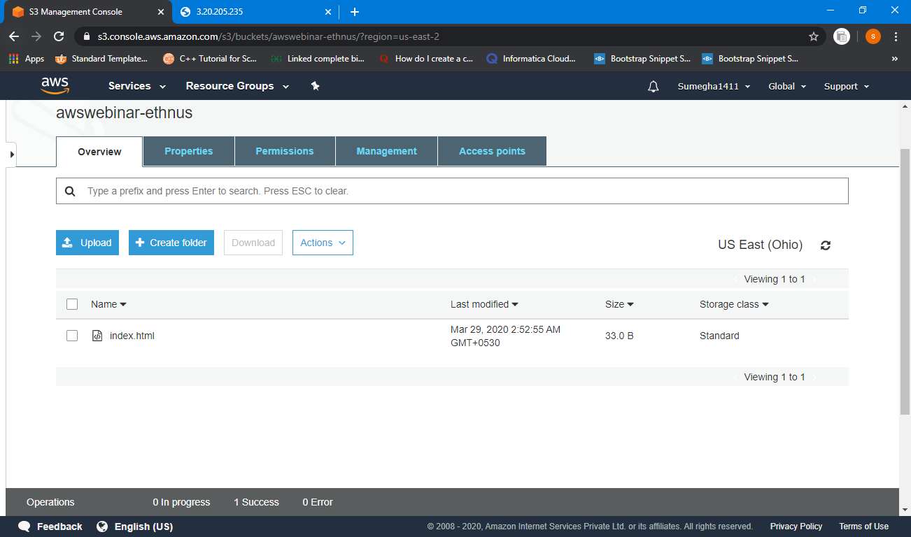

1. **ENABLING STATIC WEBSITE**

BY SELECTING USE THIS BUCKET TO HOST A WEBSITE

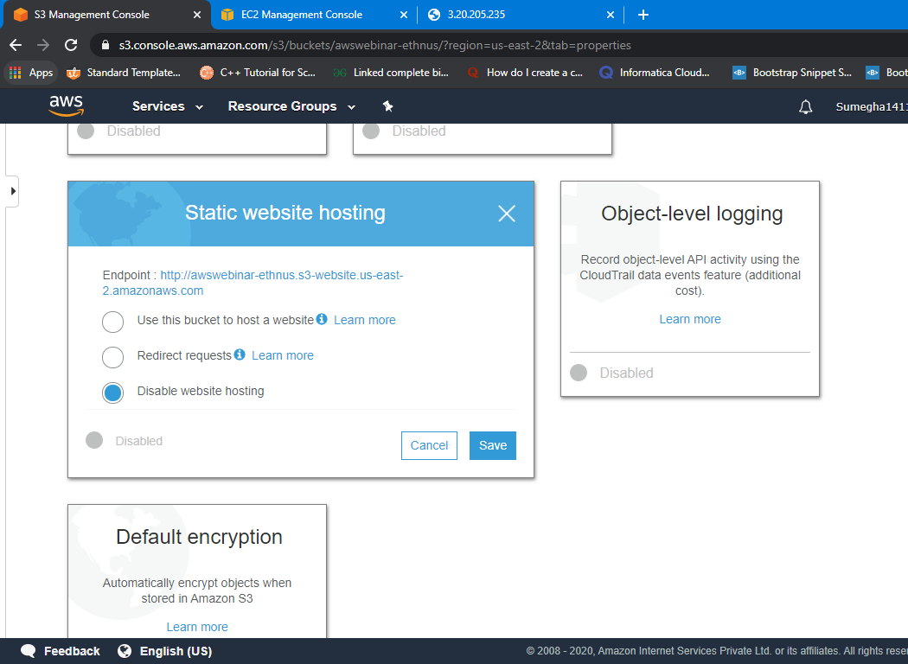

1. **MAKING OBJECT PUBLIC**

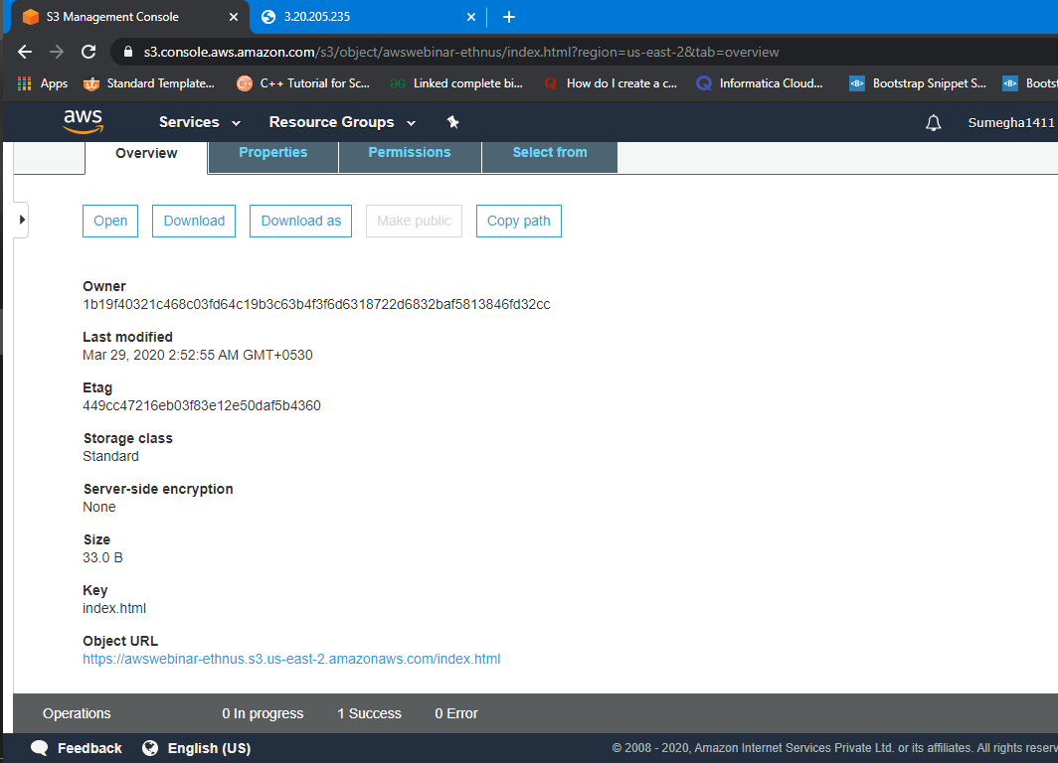

BROWSER ERROR

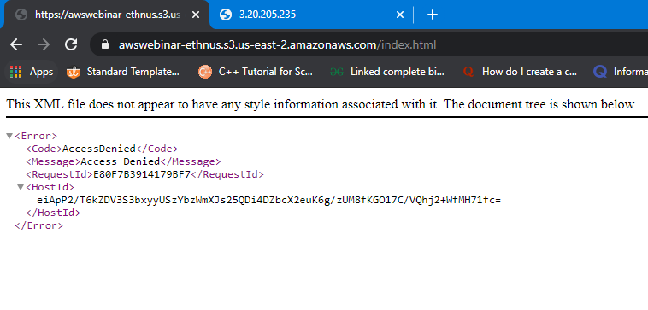

DOING BLOCK ALL PUBLIC ACCESS OFF

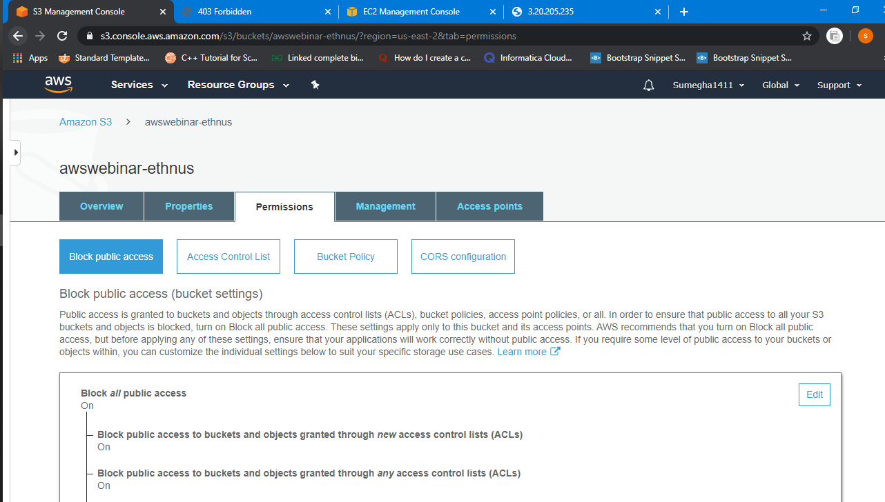

1. **CHECKING THE S3 LINK ON THE BROWSER**

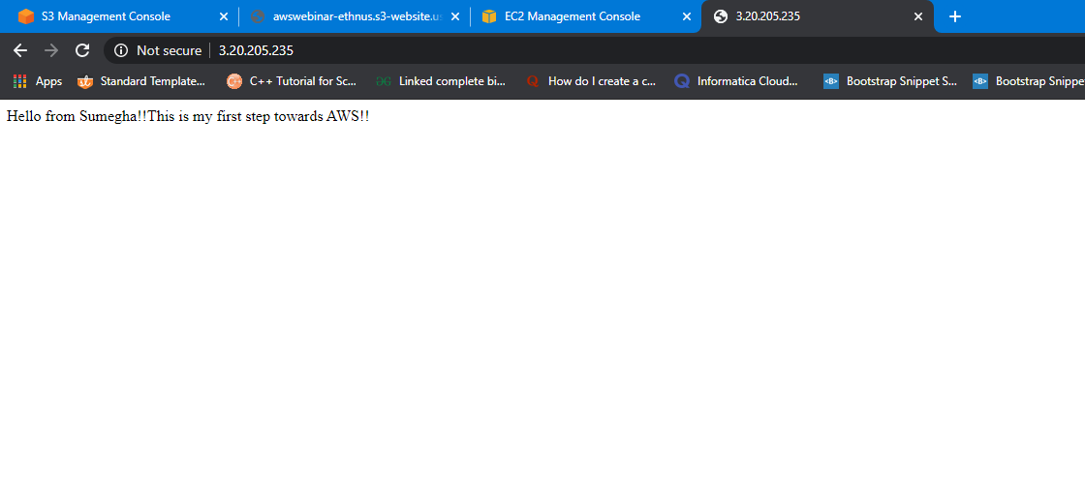

**AMAZON REKOGNITION**

1. **FACE AND OBJECT DETECT**

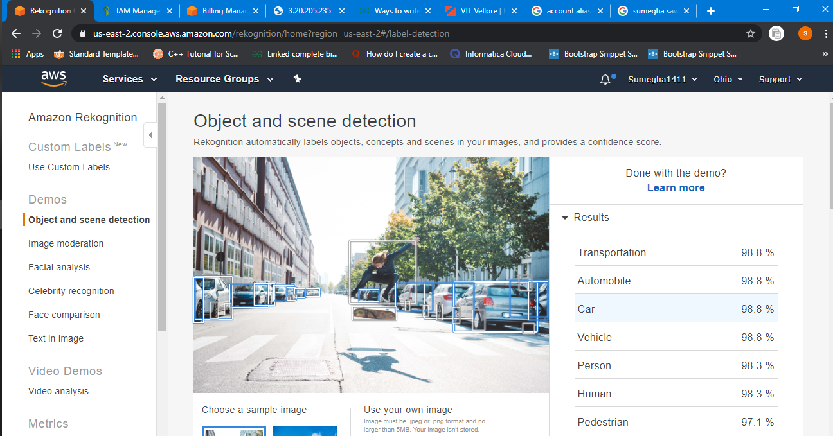

**FACIAL ANALYSIS**

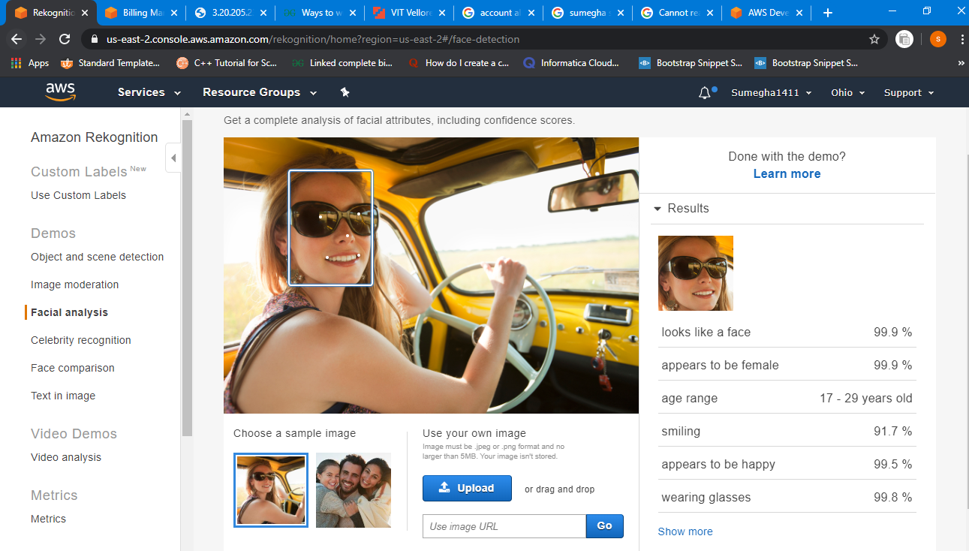

1. **FACE COMPARE**

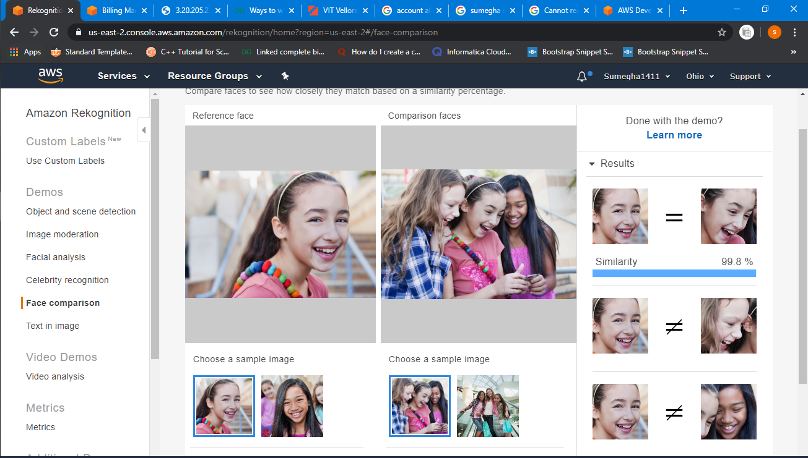

1. **CELEBRITY RECOGNITION**

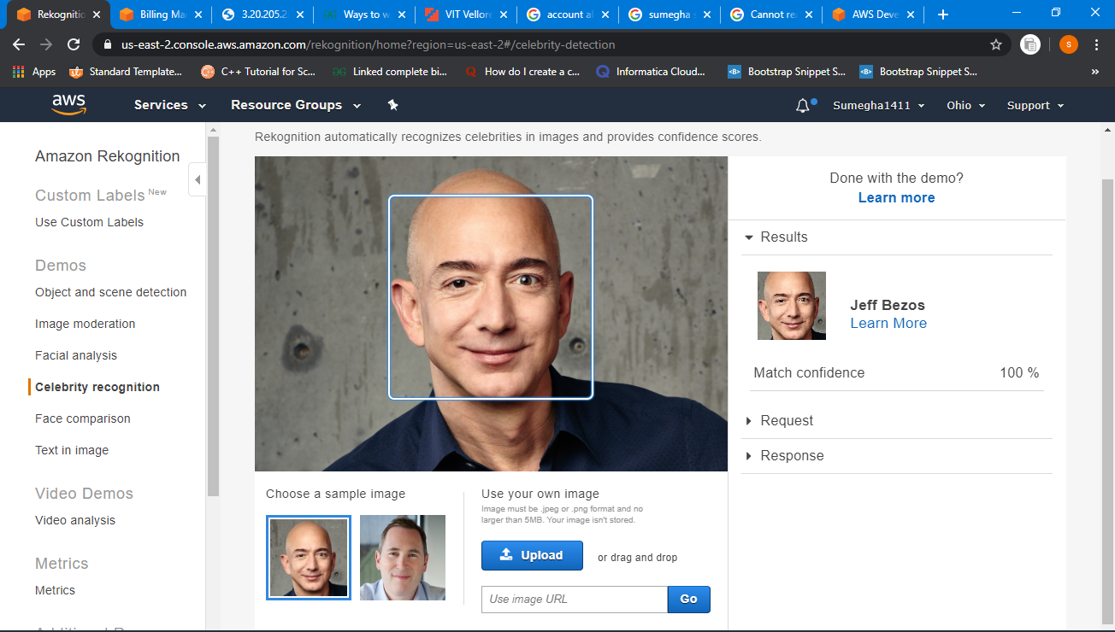

1. **TEXT IN IMAGE**

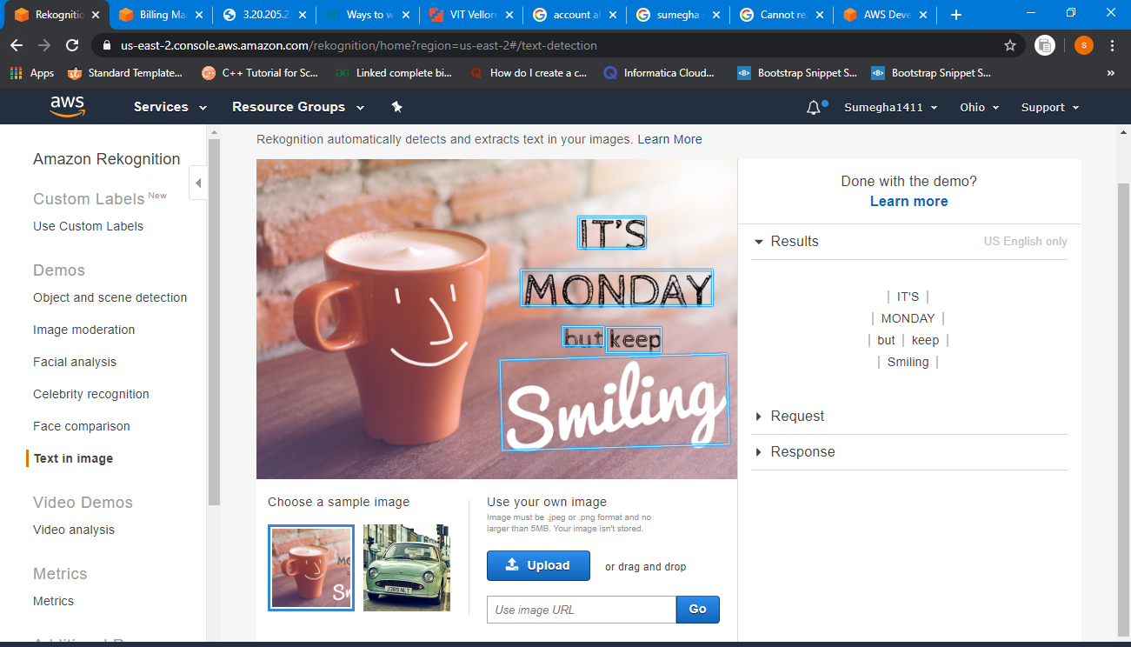

**EC2 AND S3**

**1&2. INSTALLING PHP AND INSTALLING AWS-SDK**

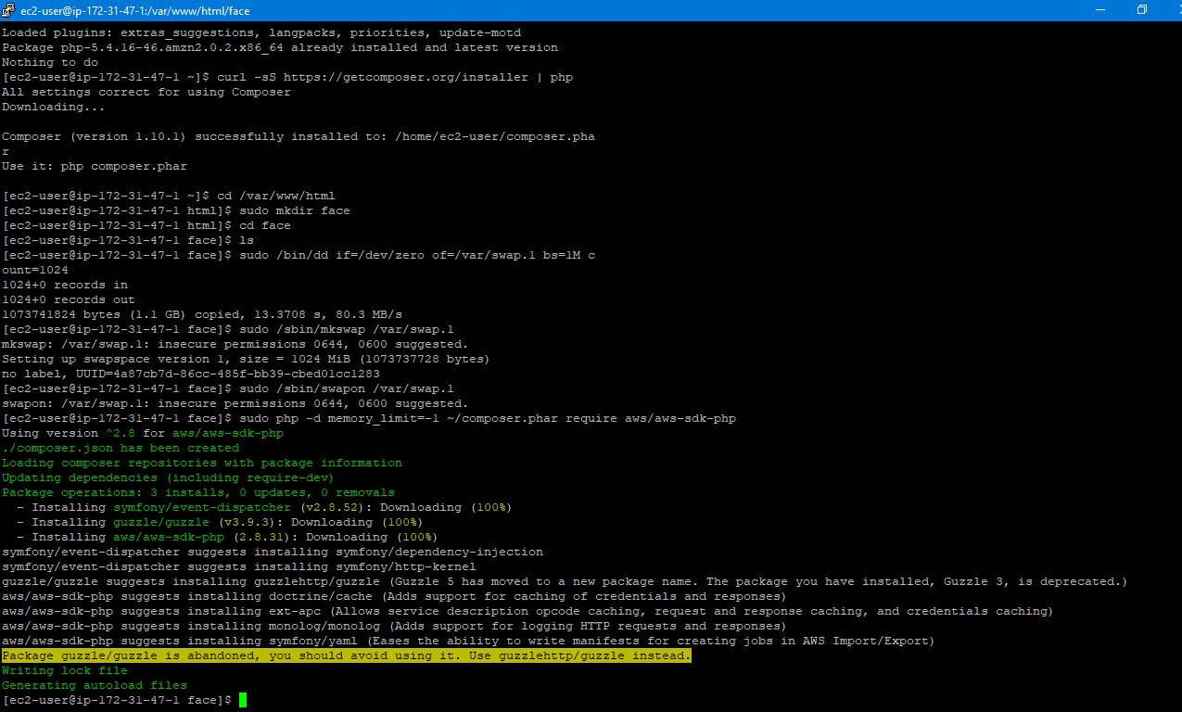

IMAGE SAVED IN FOLDER

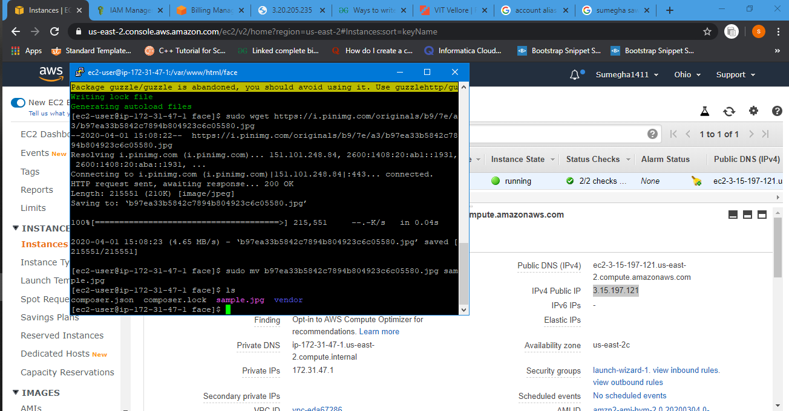

1. **INDEX.PHP FILE CODE(FINAL CODE)**

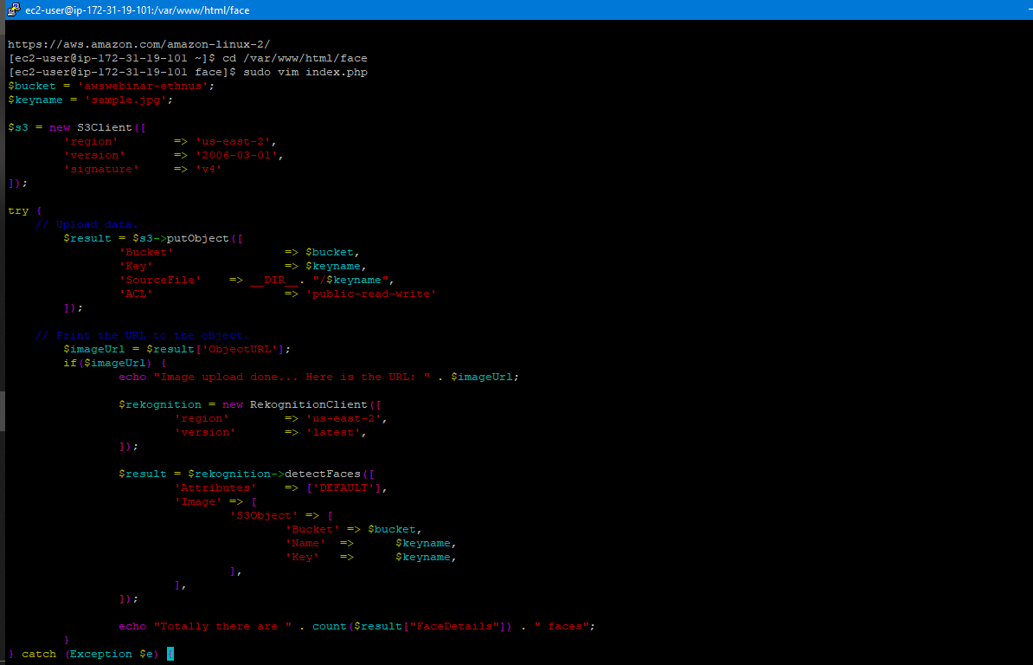

1. **UPLOAD SUCCESS SCREENSHOT**

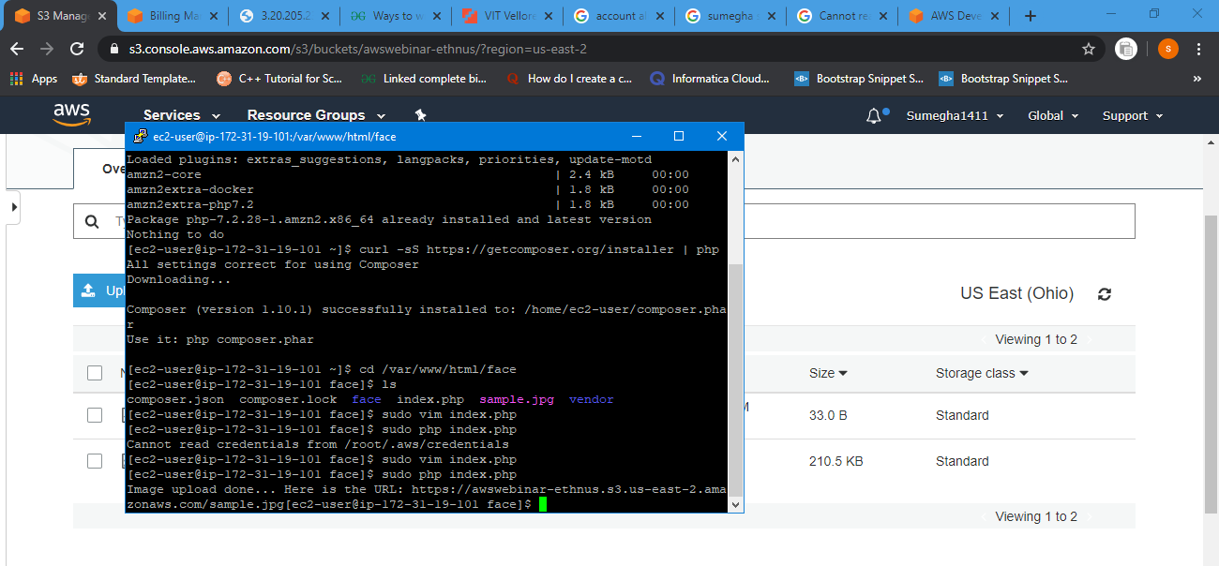

**IMAGE UPLOADED**

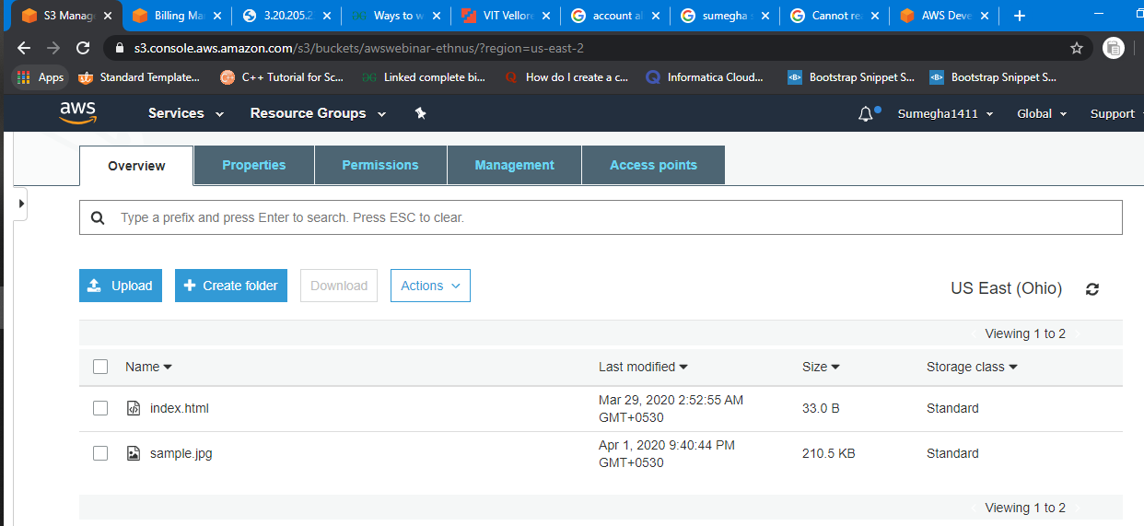

**SCREENSHOTS FOR EC2 AND REKONGNITION**

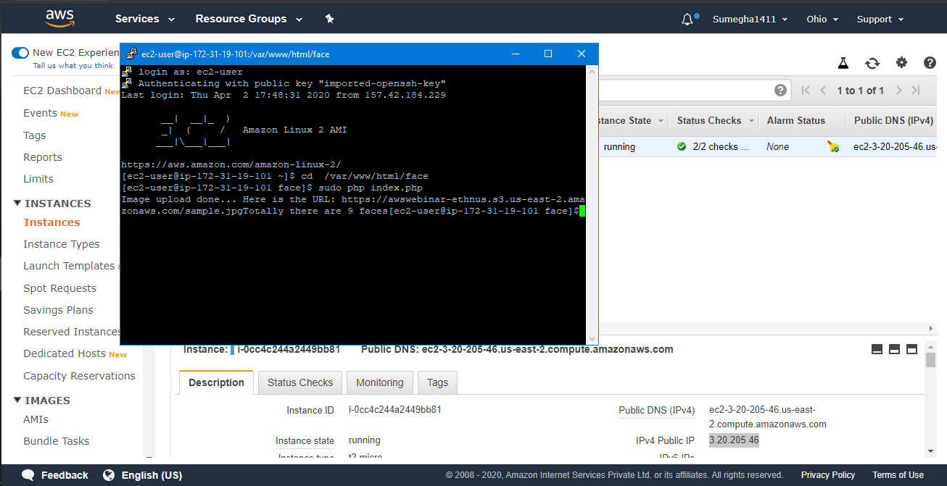

BROWSER VIEW

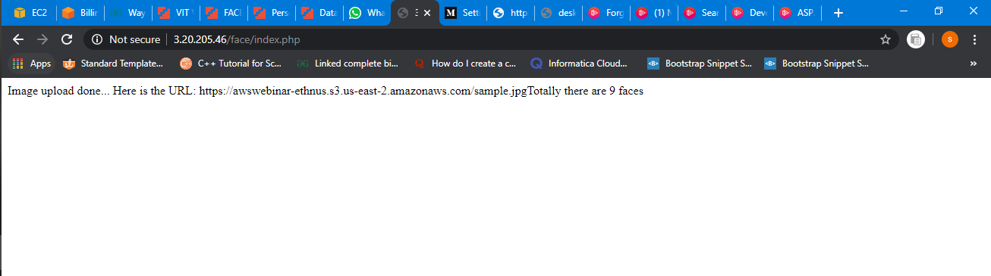

**THANK YOU!!**